**Assignment -3**

Python Programming

|  |  |
| --- | --- |
| Assignment Date | 29 September 2022 |
| Student Name | M.Suryakumar |
| Student Roll Number | 912419104033 |
| Maximum Marks | 2 Marks |

**Question-1:**

**Write python code for blinking LED and Traffic lights for Raspberry pi (Only python code is enough,no need to execute in raspberry pi).**

**Solution:-**

**PROGRAM CODING:**

**#traffic light for raspberry pi simulating in pycham with GUI**

**import turtle**

**import time**

**wn= turtle.getscreen()**

**wn.title("Stoplight By Sk")**

**wn.bgcolor("black")**

**pen= turtle.Turtle()**

**pen.color("Yellow")**

**pen.width(4)**

**pen.hideturtle()**

**pen.penup()**

**pen.goto(-30, 60)**

**pen.pendown()**

**pen.fd(60)**

**pen.rt(90)**

**pen.fd(120)**

**pen.rt(90)**

**pen.fd(60)**

**pen.rt(90)**

**pen.fd(120)**

**red_light =turtle.Turtle()**

**red_light.shape("circle")**

**red_light.color("grey")**

**red_light.penup()**

**red_light.goto(0, 40)**

**yellow_light =turtle.Turtle()**

**yellow_light.shape("circle")**

**yellow_light.color("grey")**

**yellow_light.penup()**

**yellow_light.goto(0, 0)**

**green_light =turtle.Turtle()**

**green_light.shape("circle")**

**green_light.color("grey")**

**green_light.penup()**

**green_light.goto(0, -40)**

**while True:**

**yellow_light.color("grey")**

**red_light.color("red")**

**print("Red light Blinked - Now vehicle Stop behind zebra cross..")**

**print("Blink!!")**

**time.sleep(2)**

**print("Blink!!")**

**red_light.color("grey")**

**green_light.color("green")**

**print("Green light on- Now vehicle can go..")**

**print("Blink!!")**

**time.sleep(3)**

**print("Blink!!")**

**green_light.color("grey")**

**yellow_light.color("yellow")**

**print("Yellow light Blinked- Now vehicle Ready to go..")**

**print("Blink!!")**

**time.sleep(1)**

**print("Blink!!")**

**wn.mainloop**

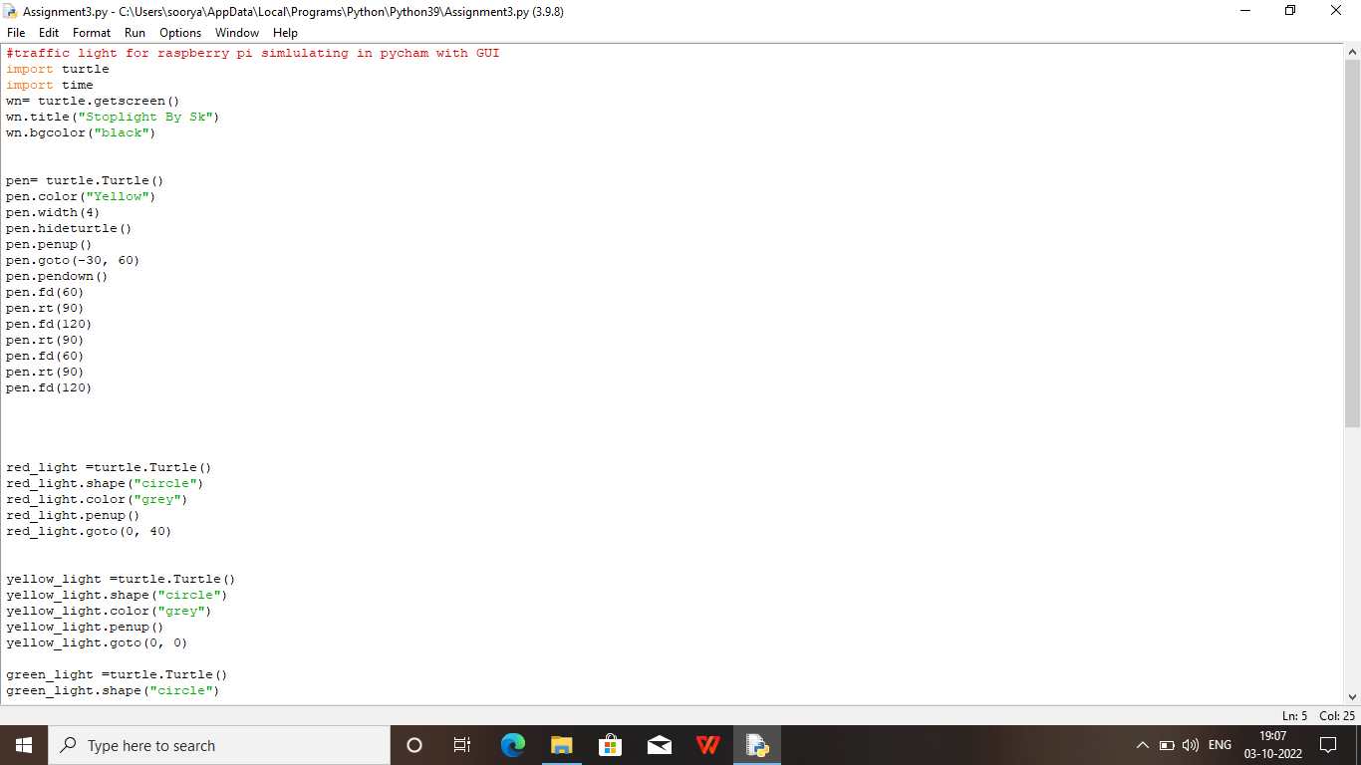

**OUTPUT:**

